Centering a Quilt Back on the Longarm
By Vicki Welsh
All information herein is provided in good faith and is for your personal use. You may not distribute the instructions without written permission from Vicki (colorwaysbyvicki.com). You are welcome to link to it at colorwaysbyvicki.com. If you find any errors in the pattern please contact Vicki so she can fix them in the electronic document.)

Having a longarm is great fun and you can do a lot of cool things with it. But when I started dyeing my own fabrics I wanted to be able add tie dyed fabrics to the back of my quilts. I eventually developed this process so that I could have perfectly centered backs on my quilts, as in this one with a tie dye spiral on the back of a Quilt of Valor.
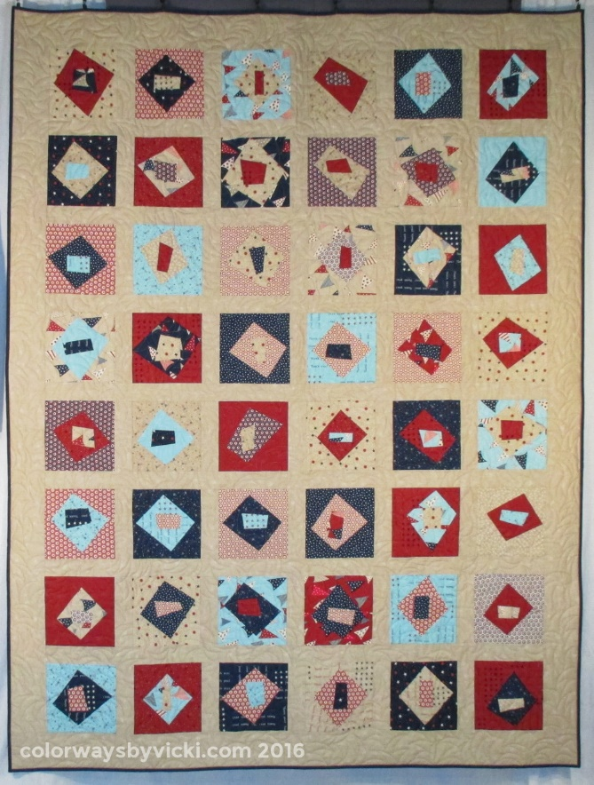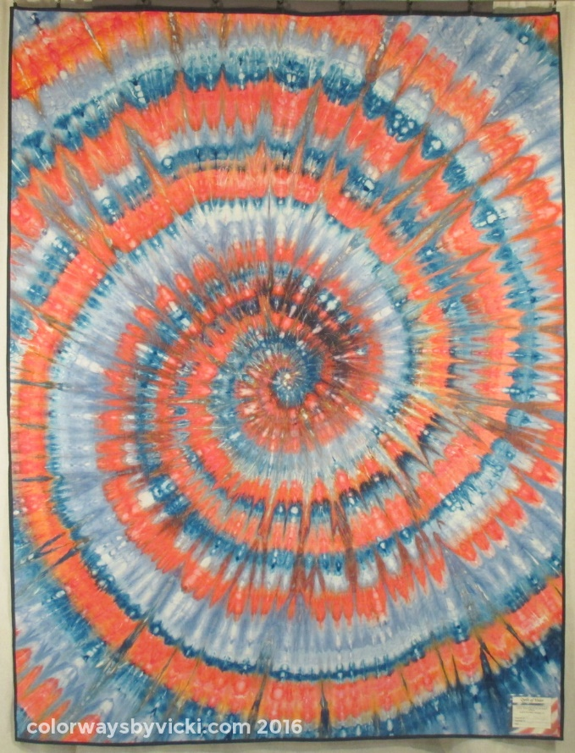
Let’s get started!

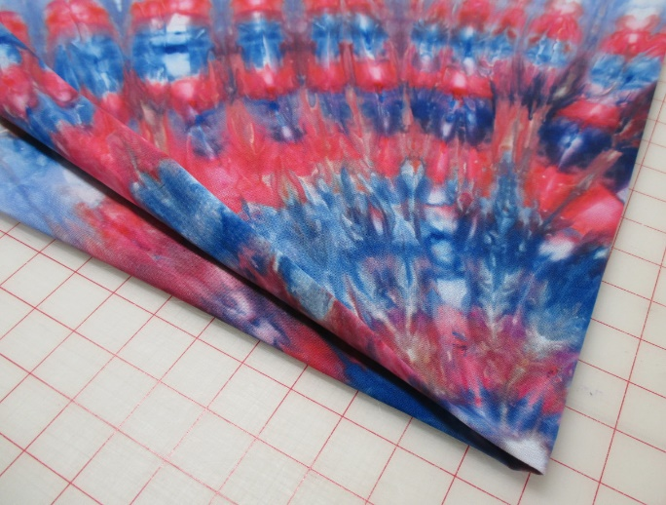
As with any other backing, this one will need to be squared up. You are probably in the habit of squaring your backing on grain or parallel with the selvedges. This time you have to square to the pattern of the backing. In this photo the backing is folded exactly along the horizontal and vertical center lines of the design. The center is that white dot.
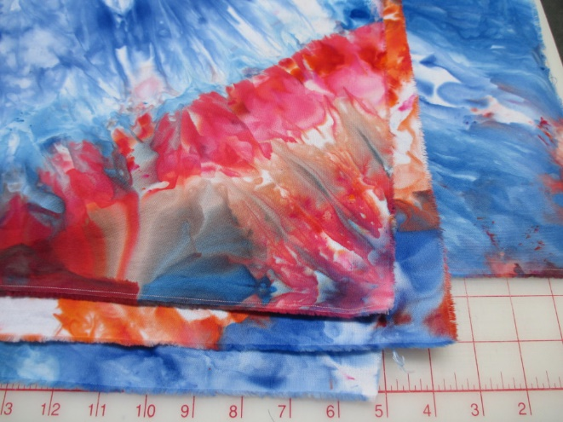
This is what the corners look like! You just have to pretend that there’s no grain.
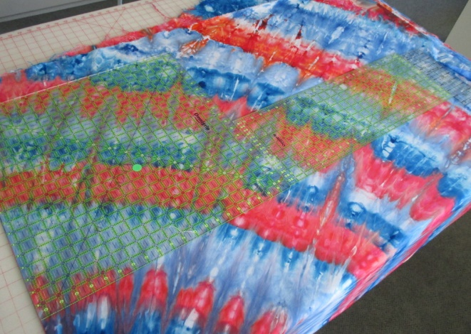
Once you have it aligned on center to the pattern, trim the backing to square the edges. Square it from the center and side fold lines, not the edge.
If you are working with a pieced back, square the edges parallel to the piecing lines.
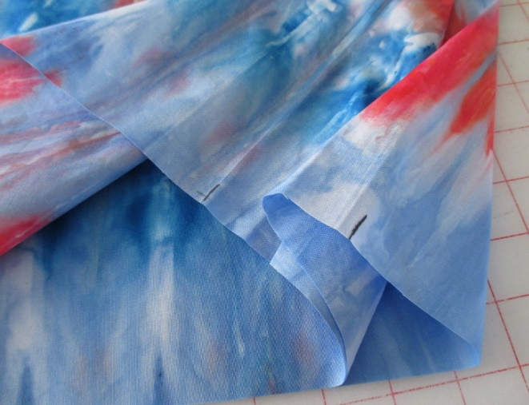
Mark the center of all 4 sides.
Now let’s load the quilt.
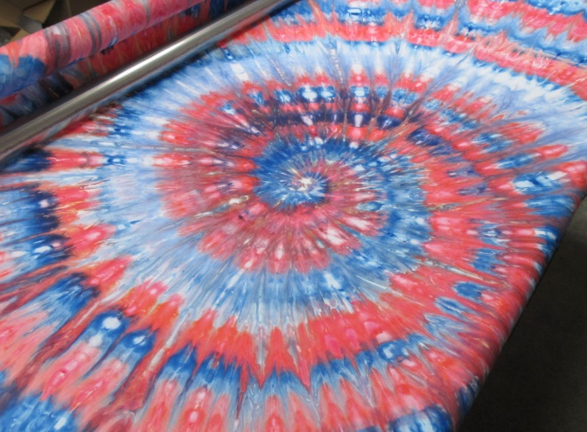
Load the backing making sure that the center of the edges that you are attaching to the leaders are centered on the leaders. Once the quilt is loaded, position the backing so that the center of the backing is in the middle of your longarm.
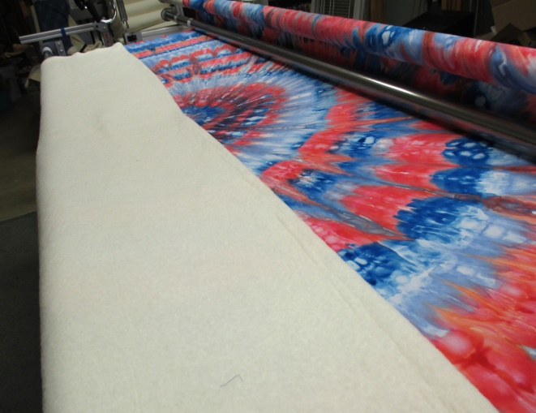
Fold your batting in half and place the folded edge along the horizontal center line of the backing.
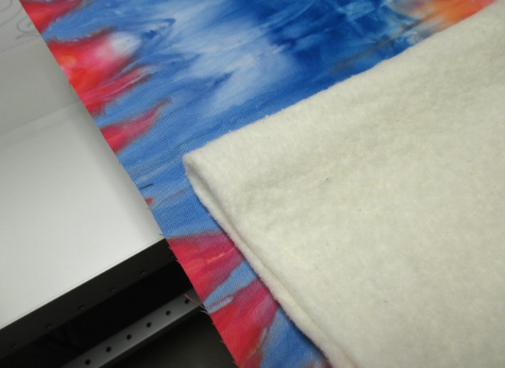
Line up the fold on each edge.
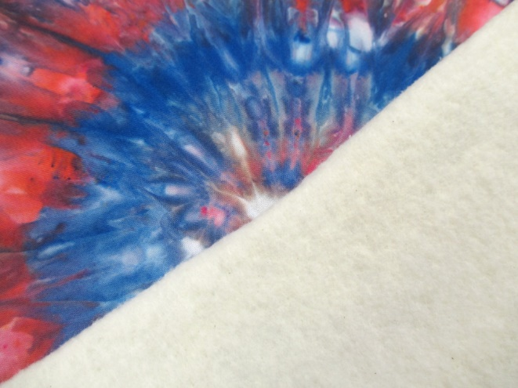
And in the center.
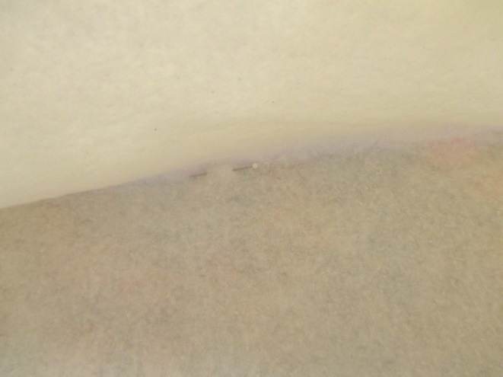
Open the batting and place some marks or pins along the fold line to transfer the center backing markings to the batting. Be sure to also mark the exact center of the backing as well. I like to put another pin crosswise at the center to mark that point.
**Make sure you remove the pins that are in the backing!
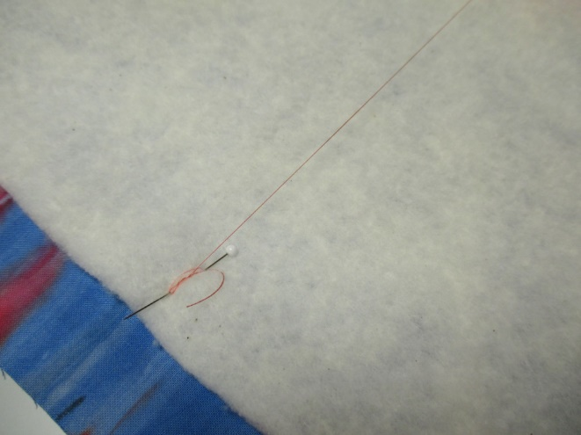
If you want to double check put a pin at the center mark on on both edges and wrap a piece of thread across the width of the batting between the edge pins. It should cross right over the center point. If it doesn’t make adjustments now.
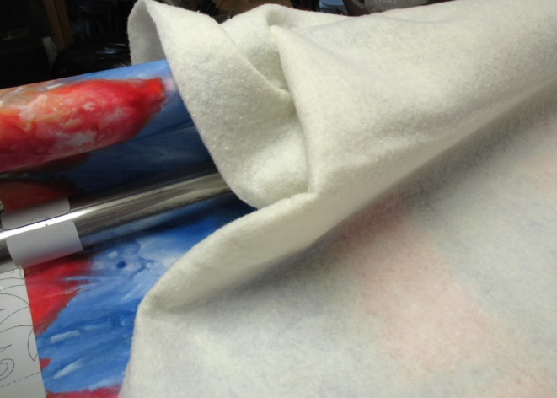
Once the batting is marked, open it up and smooth out the part of the batting that fits in the work area and bundle the rest next to the take up roller.
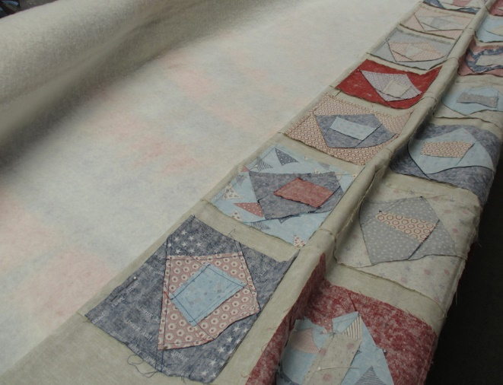
Fold the quilt top exactly in half, right sides together and mark the exact center of the quilt top. Place the folded edge of the top on the marked center line of the batting.
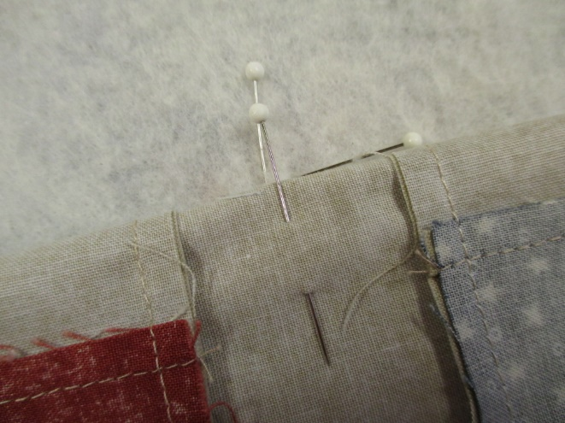
Make sure that the exact center of the quilt top aligns with the exact center marking of the backing.
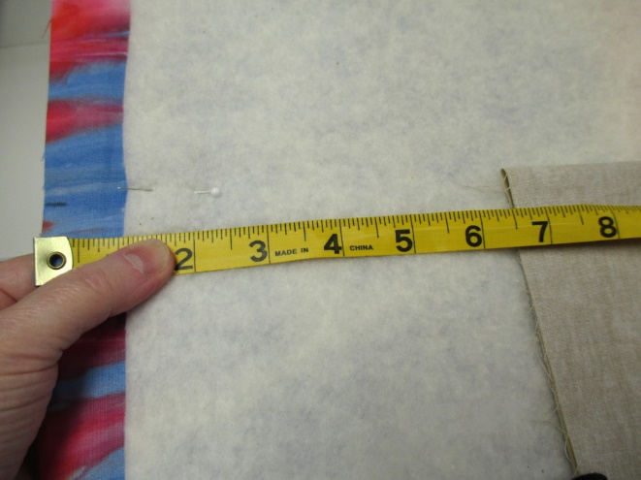
Measure from the edge of the quilt top to the edge of the backing at both ends of the quit. Make sure that your top is centered between the edges. If not, then try again, you have a measurement off somewhere. Note the distance between the edge of the top and the edge of the backing. Each time you advance the quilt check this measurement to make sure the top and back stay perfectly aligned.
***Make sure you remove the pins for the batting!
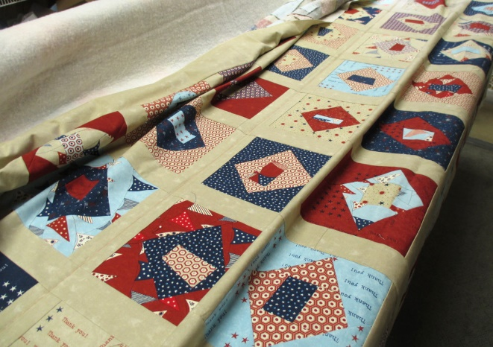
Open out the quilt top and bundle the excess top fabric near the take up roller. Just focus on the middle of the quilt. You are going to baste down the center of the quilt to stabilize the middle. I use my channel locks to make sure that I have the top perfectly positioned.
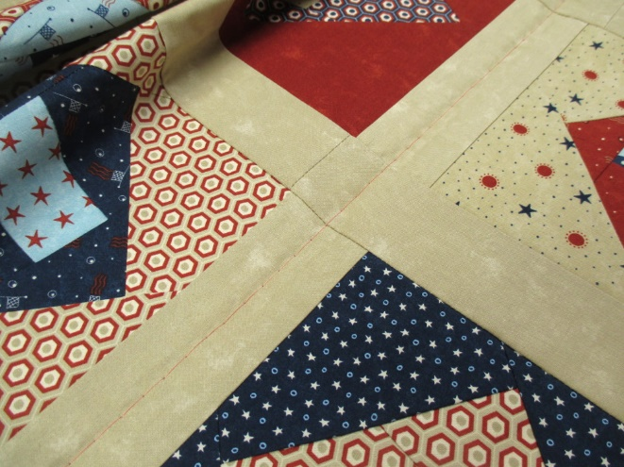
Here’s the basting stitch running down the center of the sashing.

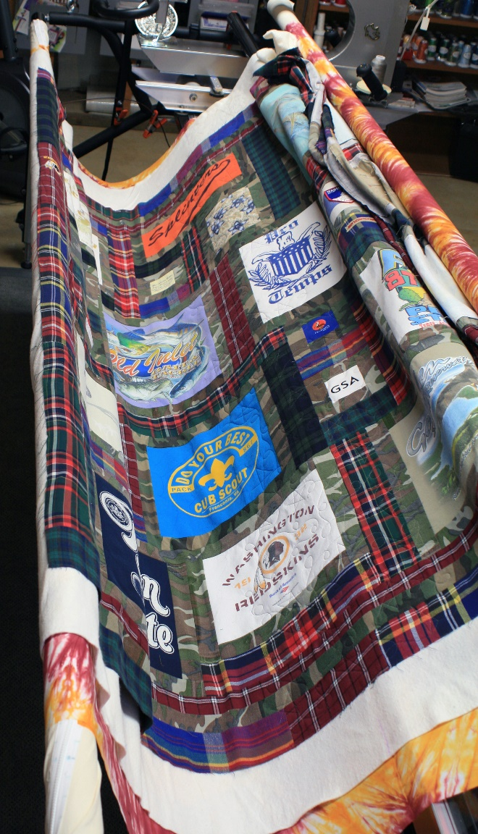
Now what? You’ve got a lot of batting and quilt top bunched at that take up roller and a bunch of batting and quilt top hanging over the front of the machine.
(Because my machine is configured unusually I’m using an older set of photos to demonstrate this part.)
Unroll the quilt back from the backing bar at the front of the machine and loosely arrange the batting and quilt top on the backing. Roll it all on the backing bar together.
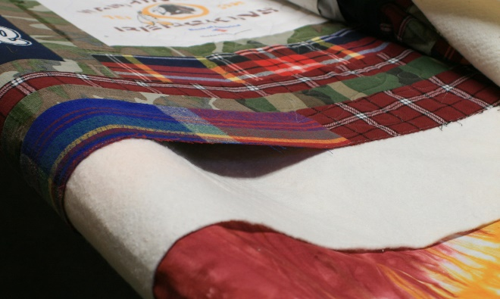
Be very careful to try to keep the layers together. If you wind up with a gap like this it’s too tight. You could tear the fabric if there’s too much strain on the area you have already quilted. Undo it and roll it again so there is no stress in this area.
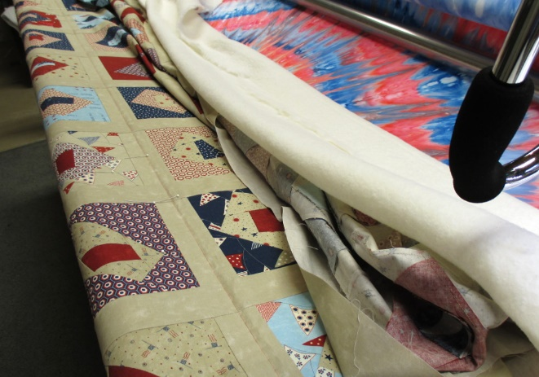
The bottom of the quilt is out of the way so you can focus on the top edge. Roll the quilt toward the backing bar so that the basted line is near the front edge.
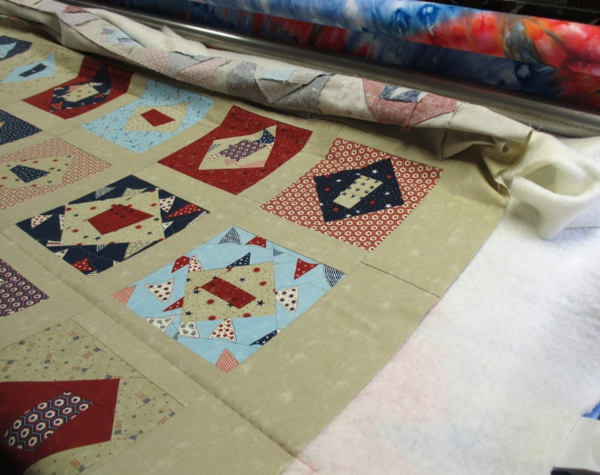
Spread the backing and top toward the take up roller. It’s OK if it all doesn’t fit yet. Just focus on the room that you have and keep the extra batting and top out of the way.
Baste the area that’s smoothed out and continue rolling and basting until the entire top is basted.
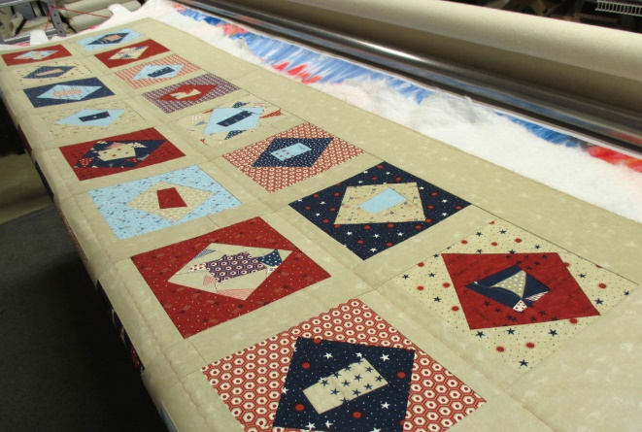
This is the reason you want to be careful about centering your batting. I had just enough batting to baste this one.
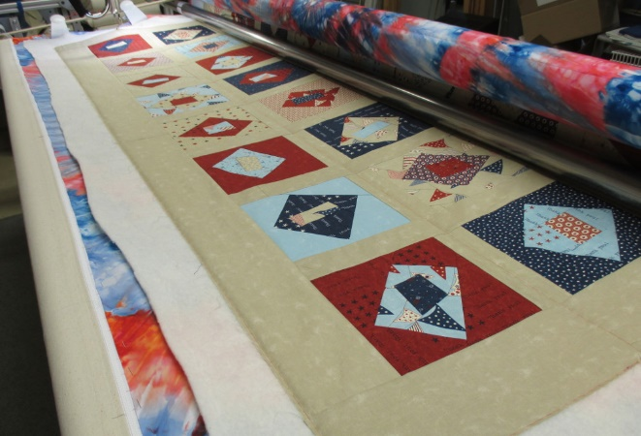
Once the top half is basted roll the quilt back to the middle, unroll the batting and top from the front roller and baste the rest of the quilt.
This technique isn’t limited to quilts that are centered on backing. It’s also works for off-center alignment. The key is to find the alignment points on the top and back and treat those as the “center” when loading the quilt.
I hope this gives you another great service to offer your customers or to make your own quilts even more special.
To the right here is another quilt that I made with a centered quilt back.
If you need a tie dyed backing for one of your quilts I can custom make any color or design combinations that you want.
